24.67: a) One can think of “infinity” as a giant conductor with 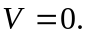
b) 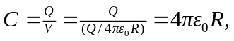 where we’ve chosen 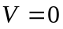 at infinity.
c) Larger than, but comparable to the capacitance of a typical capacitor in a circuit.

